Name: Puna Poudel

Assignment: Module 8.2

Due Date: 07/07/2024

Professor: Chandra Bobba

Github url: <https://github.com/punaram14/csd-310.git>

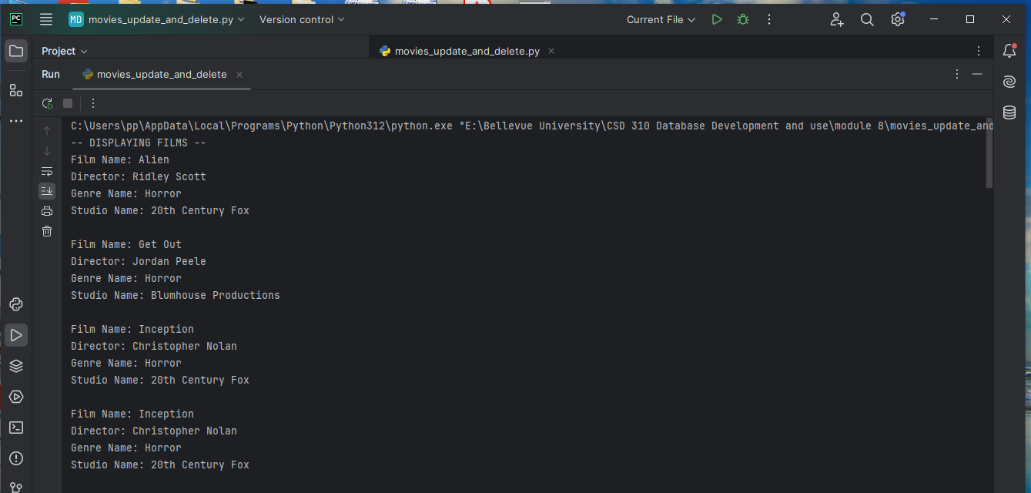

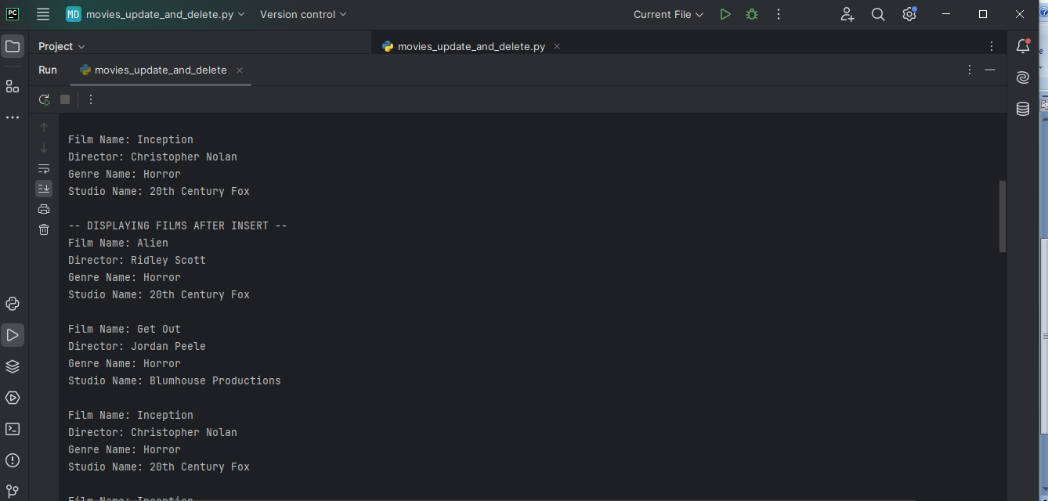

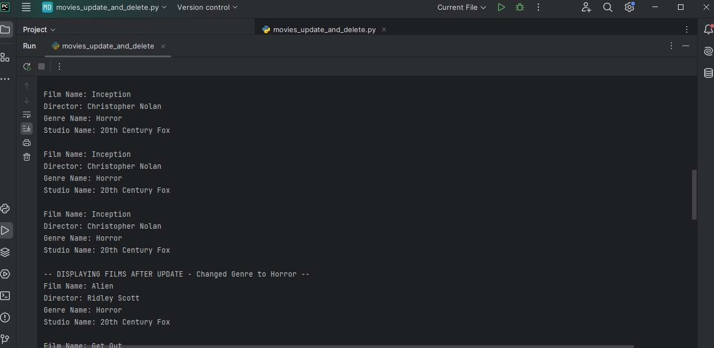

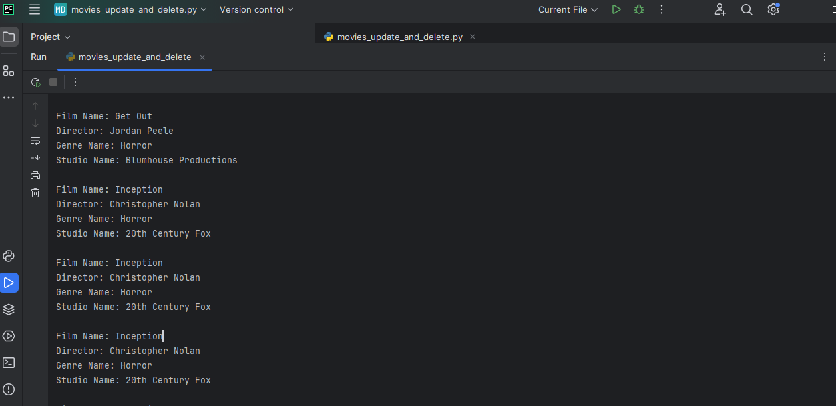

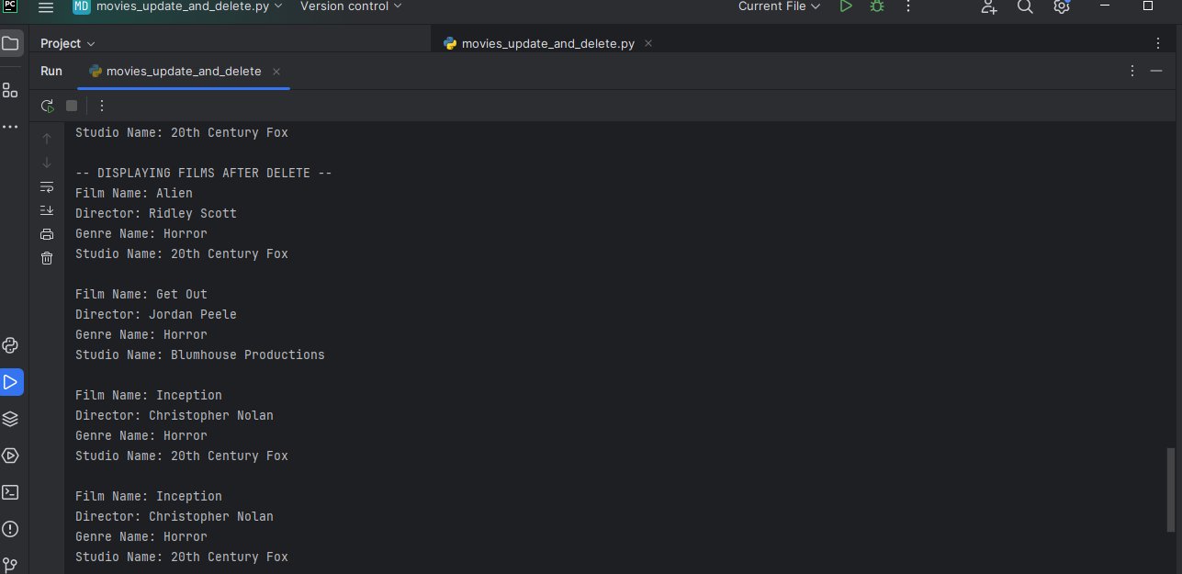

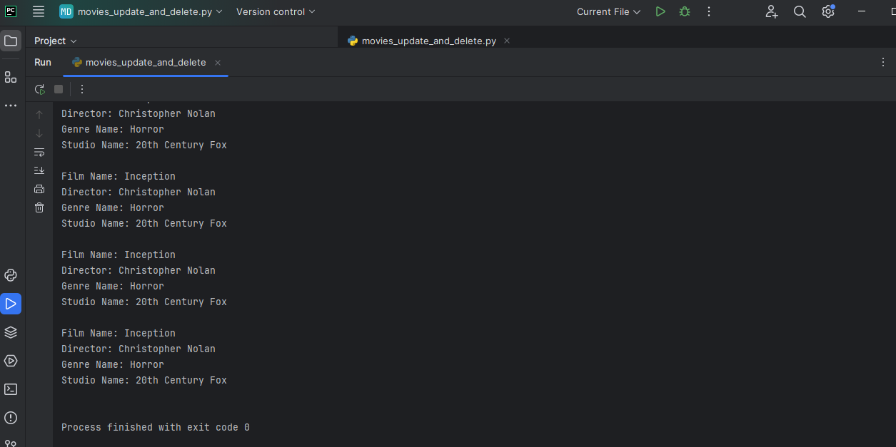

Here is the output with code:

C:\Users\pp\AppData\Local\Programs\Python\Python312\python.exe "E:\Bellevue University\CSD 310 Database Development and use\module 8\movies_update_and_delete.py"

-- DISPLAYING FILMS --

Film Name: Alien

Director: Ridley Scott

Genre Name: Horror

Studio Name: 20th Century Fox

Film Name: Get Out

Director: Jordan Peele

Genre Name: Horror

Studio Name: Blumhouse Productions

Film Name: Inception

Director: Christopher Nolan

Genre Name: Horror

Studio Name: 20th Century Fox

Film Name: Inception

Director: Christopher Nolan

Genre Name: Horror

Studio Name: 20th Century Fox

Film Name: Inception

Director: Christopher Nolan

Genre Name: Horror

Studio Name: 20th Century Fox

-- DISPLAYING FILMS AFTER INSERT --

Film Name: Alien

Director: Ridley Scott

Genre Name: Horror

Studio Name: 20th Century Fox

Film Name: Get Out

Director: Jordan Peele

Genre Name: Horror

Studio Name: Blumhouse Productions

Film Name: Inception

Director: Christopher Nolan

Genre Name: Horror

Studio Name: 20th Century Fox

Film Name: Inception

Director: Christopher Nolan

Genre Name: Horror

Studio Name: 20th Century Fox

Film Name: Inception

Director: Christopher Nolan

Genre Name: Horror

Studio Name: 20th Century Fox

Film Name: Inception

Director: Christopher Nolan

Genre Name: Horror

Studio Name: 20th Century Fox

-- DISPLAYING FILMS AFTER UPDATE - Changed Genre to Horror --

Film Name: Alien

Director: Ridley Scott

Genre Name: Horror

Studio Name: 20th Century Fox

Film Name: Get Out

Director: Jordan Peele

Genre Name: Horror

Studio Name: Blumhouse Productions

Film Name: Inception

Director: Christopher Nolan

Genre Name: Horror

Studio Name: 20th Century Fox

Film Name: Inception

Director: Christopher Nolan

Genre Name: Horror

Studio Name: 20th Century Fox

Film Name: Inception

Director: Christopher Nolan

Genre Name: Horror

Studio Name: 20th Century Fox

Film Name: Inception

Director: Christopher Nolan

Genre Name: Horror

Studio Name: 20th Century Fox

-- DISPLAYING FILMS AFTER DELETE --

Film Name: Alien

Director: Ridley Scott

Genre Name: Horror

Studio Name: 20th Century Fox

Film Name: Get Out

Director: Jordan Peele

Genre Name: Horror

Studio Name: Blumhouse Productions

Film Name: Inception

Director: Christopher Nolan

Genre Name: Horror

Studio Name: 20th Century Fox

Film Name: Inception

Director: Christopher Nolan

Genre Name: Horror

Studio Name: 20th Century Fox

Film Name: Inception

Director: Christopher Nolan

Genre Name: Horror

Studio Name: 20th Century Fox

Film Name: Inception

Director: Christopher Nolan

Genre Name: Horror

Studio Name: 20th Century Fox

Process finished with exit code 0